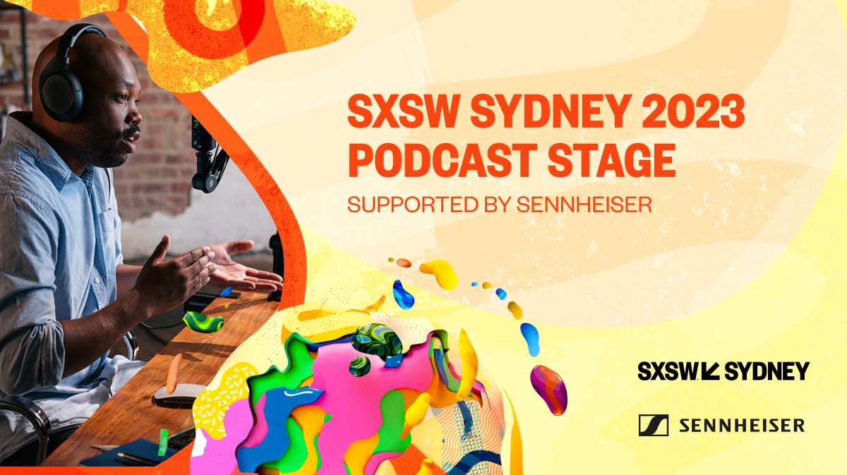
Unrivalled audio quality meets SXSW Sydney® 2023 on the Podcast Stage
Sennheiser Group named Supporting Sponsor of the SXSW Sydney Podcast Stage

Sydney. 5 October, 2023 – leading audio manufacturer Sennheiser Group has been named as the official Supporting Sponsor of the Podcast Stage for the inaugural South by Southwest (SXSW®) event in Sydney, the iconic conference and festival series’ first ever event in the Asia-Pacific market dedicated to innovation and creativity in the region, taking place October 15-22, 2023 in Sydney, Australia.

Hosting daily recording sessions with some of Australia’s most influential on-air talent, the SXSW Sydney Podcast Stage will feature industry-leading microphones and studio headphones from both Sennheiser and Neumann to ensure superior quality sound for presenters. Located on level 4 of the ICC Exhibition Halls, in room E6, visitors are invited to tune in for a week-long program of broadcasts covering a wealth of topics from mental health, sustainability, and even AI’s impact on job markets.

Sennheiser’s ANZ Pro Audio Marketing Manager, Ruth Bailey shared her enthusiasm to spotlight Sennheiser and Neumann in a partnership that is a natural fit for all involved. “Engagement with the ever-growing community of content creators locally here in Australia and across the Asia-Pacific is very important to Sennheiser. We empower artists, podcasters, streamers and beyond to share their craft with the world and that’s possible through delivery of our premium audio solutions. What better way to showcase our exceptional audio technology than to have visitors hear for themselves and experience the innovations responsible for such elevation in sound.”

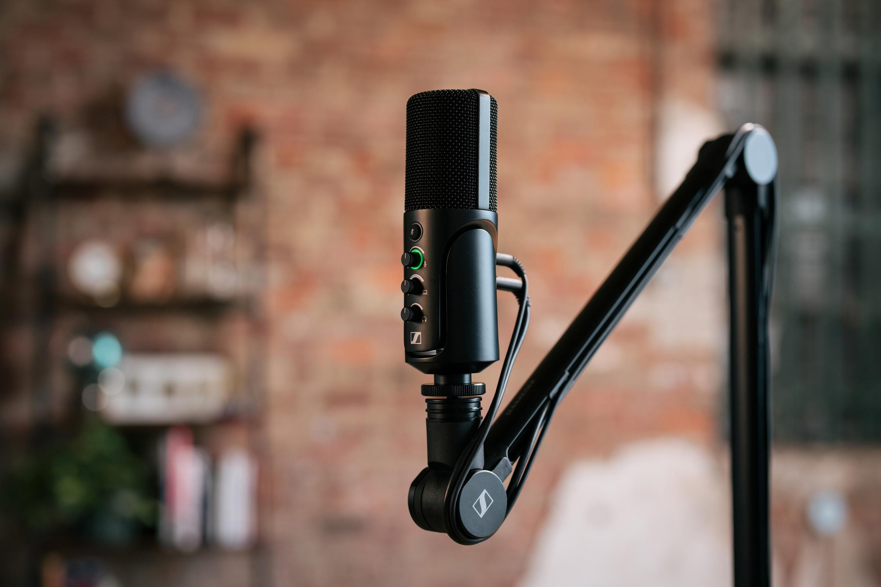
Sennheiser’s new plug-and-play solution for podcasters, streamers and creators, the Profile USB Mic will be on display at SXSW Sydney.

Highlights from the SXSW Sydney 2023 Podcast Stage include TV personality, Osher Günsberg delivering live episodes of his acclaimed podcast, Better Than Yesterday with guests including celebrated environmental activist and singer of Midnight Oil, Peter Garrett revealing how listeners can make their day better than yesterday. Australia’s much-loved satirical newspaper The Betoota Advocate will report live from the SXSW Sydney 2023 Podcast Stage.

Showcasing its suite of audio solutions perfect for content creators, podcasters, streamers and vloggers alike, Sennheiser will also exhibit at the SXSW Sydney 2023 Tech and Innovation Expo. Located on level 5, booth #1560, visitors will have the chance to get up close and personal with Sennheiser’s latest innovations – including the Profile USB Microphone which is an ideal entry point to podcasting and Sennheiser Mobile Kits designed for content creators on the move. Visitors will also have the chance to go in the running to win an exclusive giftpack to bring their content creator dreams to life.
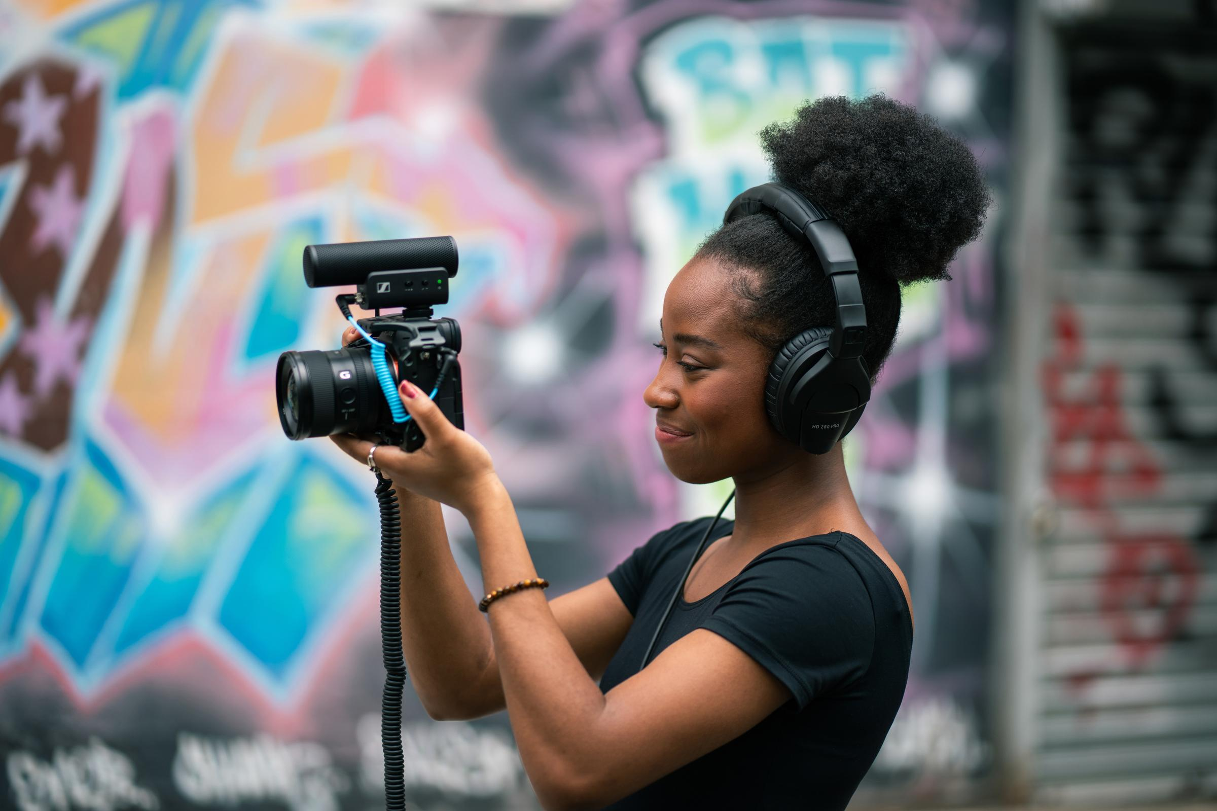
Sennheiser’s collection of camera microphones and mobile kits like the MKE 400 pictured here will be presented at the SXSW Tech and Innovation Expo.

SXSW Sydney will feature over 300 artists from well-known international acts to emerging local talent. Hosted by Young Henrys, those performing will gain access to an exclusive Artist Lounge featuring a live sound set up from Sennheiser and Neumann. Showcasing the very best of live performance solutions, experts will be on hand to support artists in elevating their audio.

More information about Sennheiser Group at SXSW Sydney can be found here. ​To book an appointment during the event, please get in touch with the press contact listed below.

SXSW Podcast Stage: Monday 16th – Friday 20th October
ICC Exhibition Halls, Level 4, Room E6, 10:00am – 6:00pm

SXSW Tech and Innovation Expo: Wednesday 18th – Saturday 21st October
ICC Exhibition Halls, Level 5, Stand #1560, 10:00am – 5:00pm

SXSW Artist Lounge: Wednesday 18th – Saturday 21st October
The Loft, UTS (backstage) hosted by Young Henrys

About the Sennheiser Group
Building the future of audio and creating unique sound experiences for our customers - this is the aspiration that unites the employees of the Sennheiser Group worldwide. The independent family-owned company Sennheiser was founded in 1945. Today, it is managed in the third generation by Dr. Andreas Sennheiser and Daniel Sennheiser and is one of the leading manufacturers in the field of professional audio technology. Within the Sennheiser Group are Georg Neumann GmbH (Berlin, Germany), manufacturer of studio-grade audio equipment; Dear Reality GmbH (Düsseldorf, Germany), known for its binaural, Ambisonics, and multichannel encoders with realistic room virtualization; and Merging Technologies SA (Puidoux, Switzerland), specialist in high-resolution digital audio recording systems.
sennheiser.com | neumann.com | dear-reality.com | merging.com

Global Press Contacts Local Press Contact
Daniella Kohan Hotwire Australia for Sennheiser ANZ
daniella.kohan@sennheiser.com sennheiseranz@hotwireglobal.com
+1 (860) 227-2235

